Southern Comfort Animal Rescue, Inc. (SoCo Rescue)
Pet Adoption Information Sheet
www.socorescue.com socorescue@yahoo.com www.facebook.com/pages/SoCo-Rescue

Congratulations! You have adopted: Macon (ID: C120824-2) Date: , 2013

Pet Description

Species: Dog Sex: Male
Est. Age: 3 years Weight: 35 lbs

Breed: Black Lab mix

Description: Black

Macon-Jan. 2013
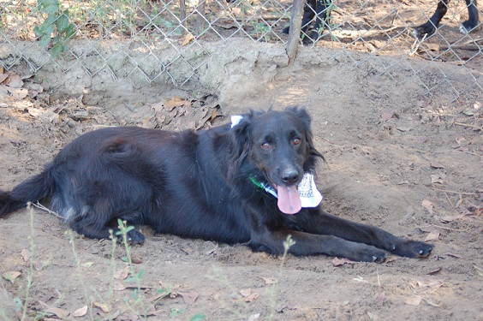

Macon’s story
Macon was found, as a stray, in the Macon, Ga. area along with another dog (see Marli)
Macon has a great disposition and gets along great with everyone he meets, be it another dog or a human.
Macon has been neutered, had all of his vaccines renewed and has been micro-chipped. He did test slightly positive for heart worms, but continued use of a monthly preventative, also known as the “Slow Kill” method of treating heart worms, should have him clear of the worms within a year’s time.
Macon is currently living as an outdoor dog, but he has shown evidence of once being an indoor dog. With a little training, Macon should excel as an indoor pet.

Medical Information:
Services: Date: Due: Performed by:
DHLPP: 11/08/12 11/08/13 Hall-Barrs Animal Clinic
Altered: 11/08/12 N/A Hall-Barrs Animal Clinic
Dewormer: 11/08/12 05/08/13 SoCo Rescue
Bordetella: 11/08/12 05/08/13 Hall-Barrs Animal Clinic
Rabies: 11/08/12 11/08/13 Hall-Barrs Animal Clinic
Tag # 121575
Micro-chip:
Tag #

Heart worm/flea preventative started: Aug. 2012

(Heart worm preventatives are administered on the first of each month.)

HEARTWORM TREATMENT METHOD
and Continued care

PLEASE maintain monthly heartworm preventatives to prevent heartworm disease! One mosquito bite can infect your pet! Consult your vet for a recommendation on which monthly heart worm preventative your new pet should be administered.
SoCo Rescue uses liquid Ivermectin as a monthly heart worm preventative and general wormer.

DIET: Your pet has been eating dry kibble such as Pedigree or Purina. We feed a 21% protein – 10 % fat mix which helps to keep stool solid.

IF YOU EXPERIENCE ANY PROBLEMS:
Please feel free to contact us or call us anytime. We are devoted to our rescues and will assist adapting your new pet to your home in any way we can. After giving the animal time to adjust to new surroundings, if you ultimately feel this adoption is inappropriate for you, for this animal or for your other pets, please notify us rather than passing this pet along. We will gladly take this pet back into our rescue.
Southern Comfort Animal Rescue, Inc
Scott Bennett 912-423-0145 socorescue@yahoo.com
www.socorescue.com/socorescue@yahoo.com
A State of Ga Dept of Agriculture licensed rescue
-and-
Registered non-profit Organization

