Southern Comfort Animal Rescue, Inc. (SoCo Rescue)
Pet Adoption Information Sheet
www.socorescue.com socorescue@yahoo.com www.facebook.com/pages/SoCo-Rescue

Congratulations! You have adopted: Marli (ID: C120824-1) Date: , 2013

Pet Description

Species: Dog Sex: Female
Est. Age: 6 years Weight: 30 lbs

Breed: Affenpinscher mix

Description: Black long hair

Marli-Jan. 2013
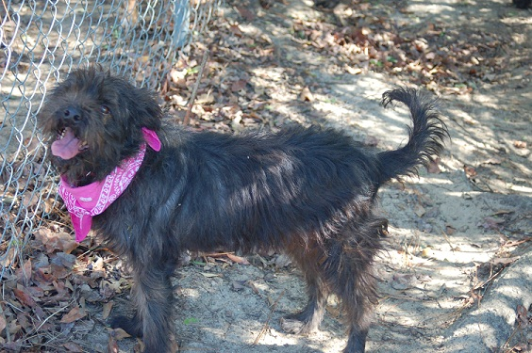

Marli’s story
Marli was found, as a stray, in the Macon, Ga. area. She looks to be an Affenpinscher mix and about 6 years old.
Marli is a very friendly girl, getting along great with other dogs and people alike. She is leash trained and loves to go on walks. Marli always seems to have a smile on her face.
While Marli is currently being kept as an outside dog, she does exhibit some qualities that lead us to believe she’s been accustomed to indoor living.
Marli has been spayed, had all of her vaccines renewed and even tested negative for heart worms. Other than her teeth being worned down, she is a very healthy dog. Marli has also been micro-chipped.

Medical Information:
Services: Date: Due: Performed by:
DHLPP: 11/08/12 11/08/13 Hall-Barrs Animal Clinic
Altered: 11/08/12 N/A Hall-Barrs Animal Clinic
Dewormer: 11/08/12 05/08/13 SoCo Rescue
Bordetella: 11/08/12 05/08/13 Hall-Barrs Animal Clinic
Rabies: 11/08/12 11/08/13 Hall-Barrs Animal Clinic
Tag # 121576
Micro-chip:
Tag #

Heart worm/flea preventative started: Aug. 2012

(Heart worm preventatives are administered on the first of each month.)

HEARTWORM TREATMENT METHOD
and Continued care

PLEASE maintain monthly heartworm preventatives to prevent heartworm disease! One mosquito bite can infect your pet! Consult your vet for a recommendation on which monthly heart worm preventative your new pet should be administered.
SoCo Rescue uses liquid Ivermectin as a monthly heart worm preventative and general wormer.

DIET: Your pet has been eating dry kibble such as Pedigree or Purina. We feed a 21% protein – 10 % fat mix which helps to keep stool solid.

IF YOU EXPERIENCE ANY PROBLEMS:
Please feel free to contact us or call us anytime. We are devoted to our rescues and will assist adapting your new pet to your home in any way we can. After giving the animal time to adjust to new surroundings, if you ultimately feel this adoption is inappropriate for you, for this animal or for your other pets, please notify us rather than passing this pet along. We will gladly take this pet back into our rescue.
Southern Comfort Animal Rescue, Inc
Scott Bennett 912-423-0145 socorescue@yahoo.com
www.socorescue.com/socorescue@yahoo.com
A State of Ga Dept of Agriculture licensed rescue
-and-
Registered non-profit Organization

